**BuzzyDoc**

**Url** : <http://integrateortho1.sourcefuse.com/admin/login>

**Credentials :** admin/demo

Once Super Admin Login to the website following page will be shown

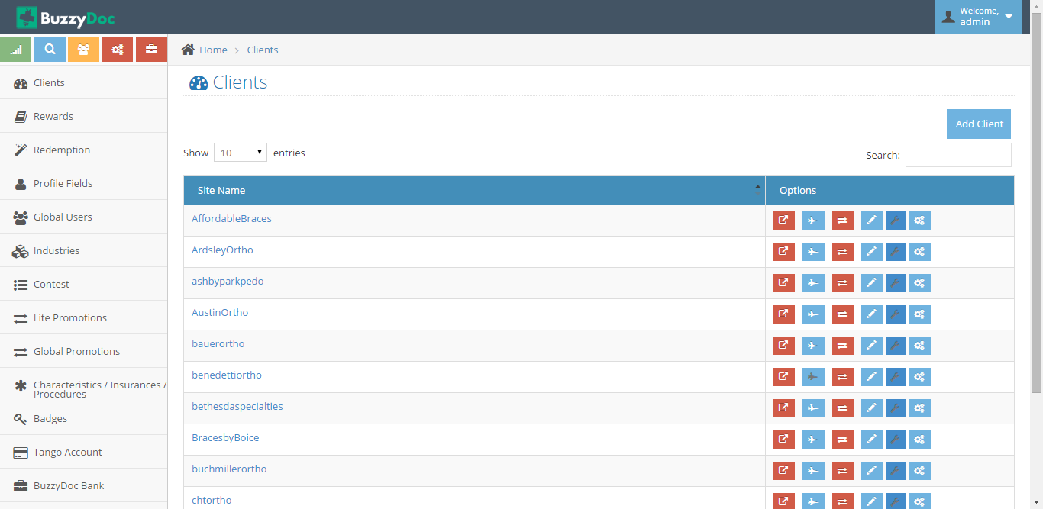

1. **Clients**

Clients basically are the multiple customers for BuzzyDoc

Super Admin can Add/Edit/Assign Cards/Login to client’s staff site/Sync etc

**Add Clients**

On Clients, click on Add Clients

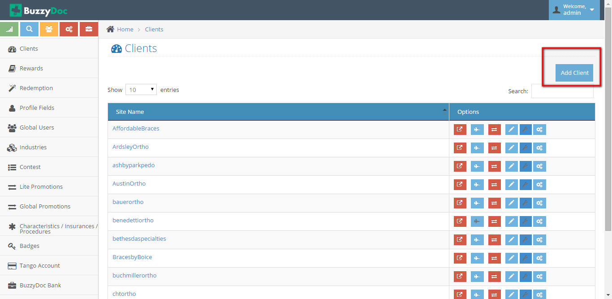

On clicking Add Client following page will be redirected

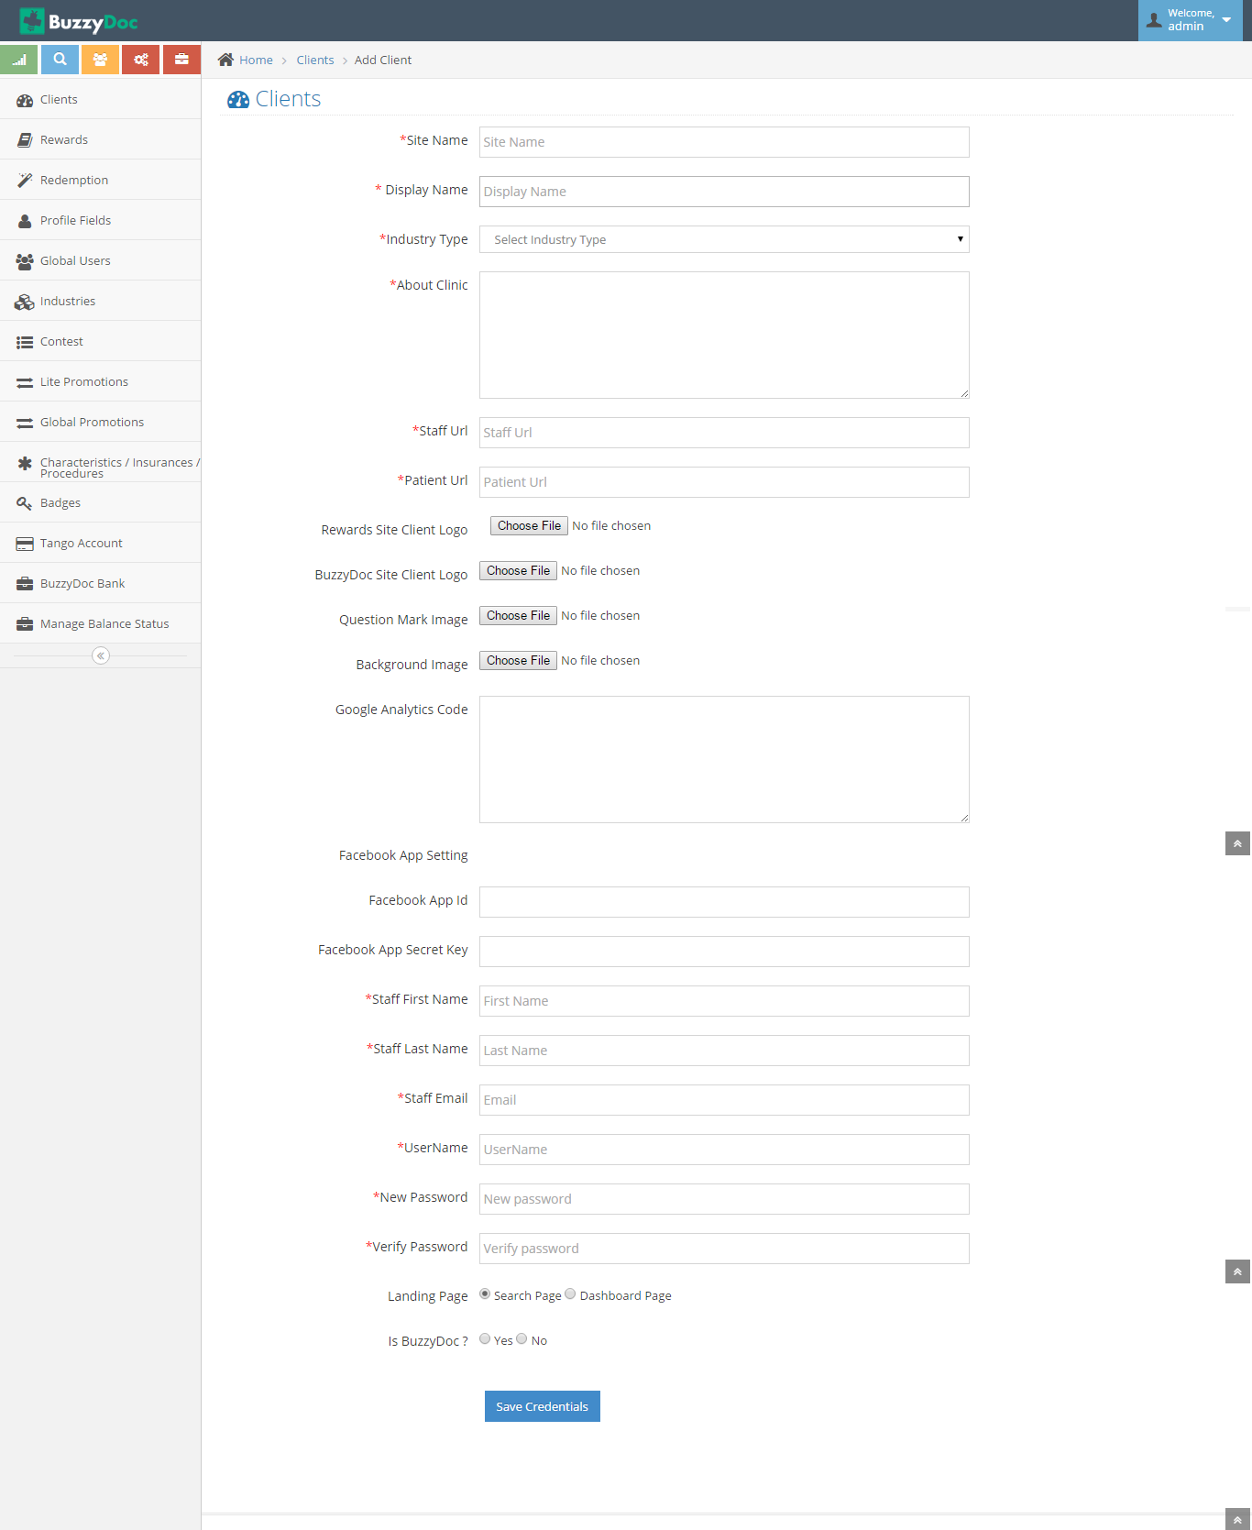

On Adding all the fields and thus clicking on Save Credentials New Client will be added to Buzzydoc

**Edit Clients**

Super Admin can Edit a client by clicking on Edit button corresponding to Client’s Name

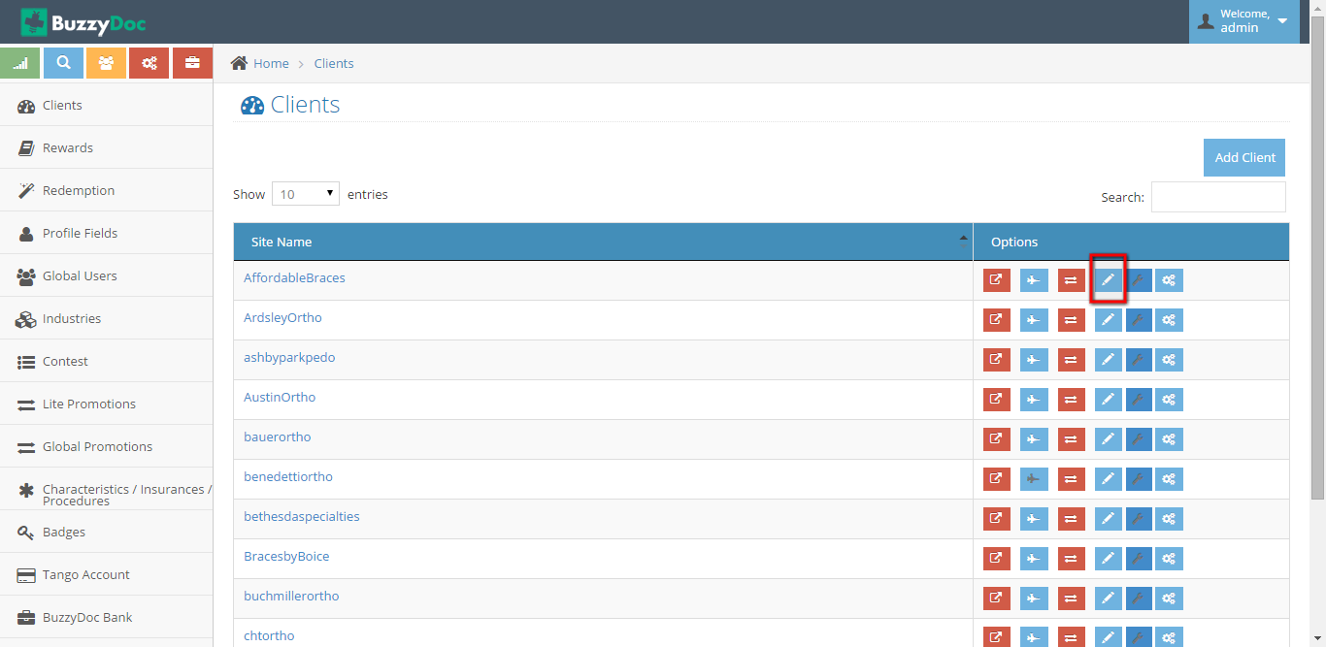

On Clicking Edit Client button Page will be redirected to Client Information page where Super Admin can change the details

**Assign Cards**

On adding a client, Super Admin can assign cards to the clients so that client can use it to identify its customer’s.

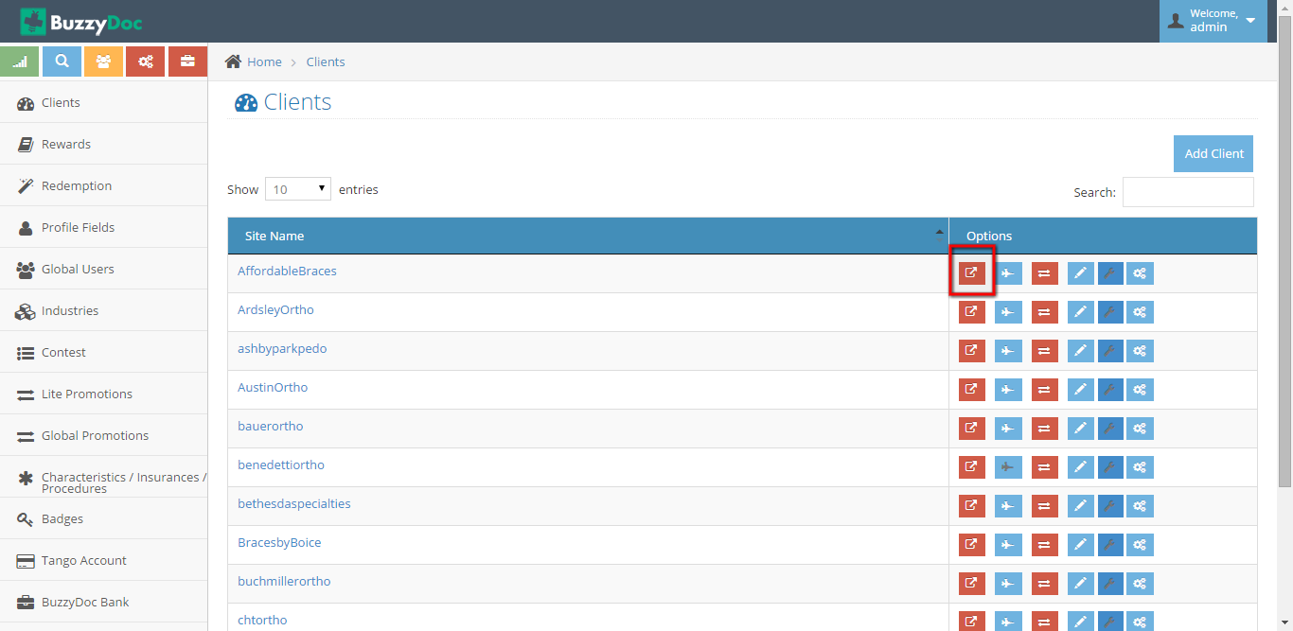

On Clicking Assign Cards Button page will be redirected to as shown:

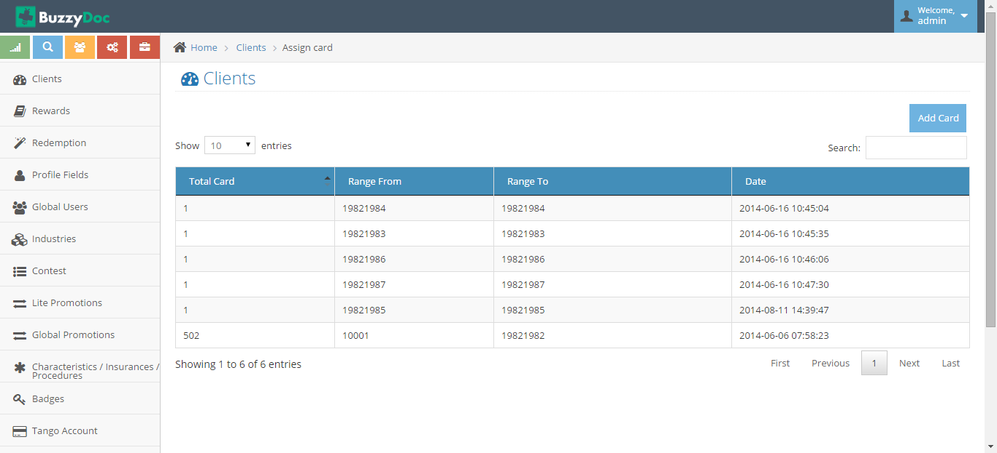

Super Admin can view all the Cards assigned previously and can Add new Card by clicking “Add Card”

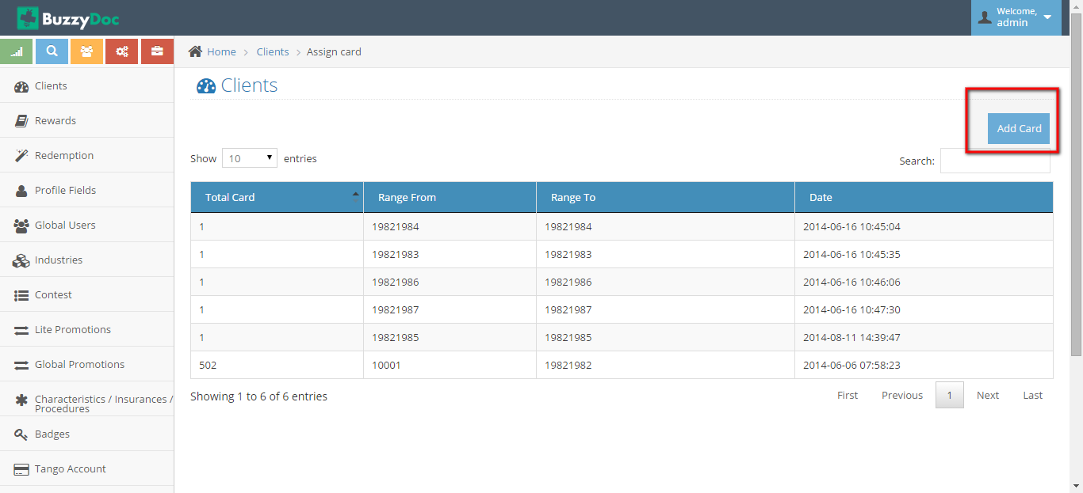

On Clicking Add Card form will open in which Super Admin has to define How many cards to be assigned for that client by defining **Number of cards,Range From and Range To**

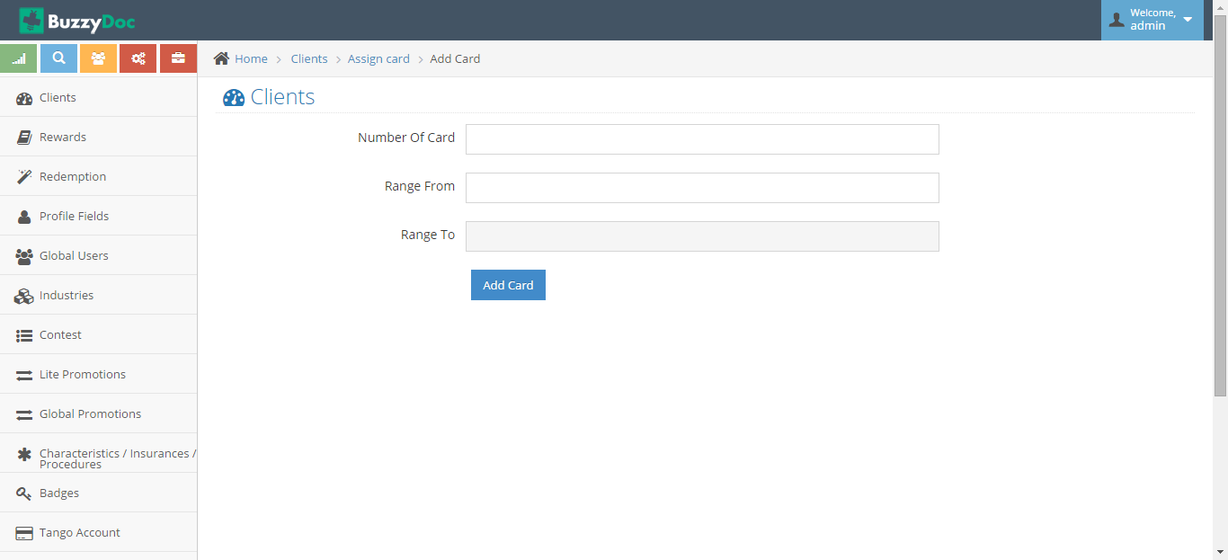

**Login to Staff Site**

Super Admin can Login to Clients Staff Site by clicking “Login to staff” button next to Client Name

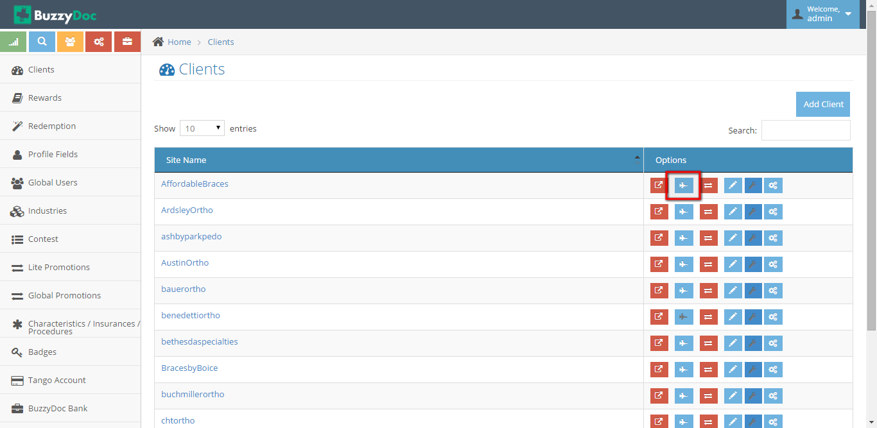

On Clicking to “Login to Staff” button popup shows up which ask to select which staff member you want to login as.

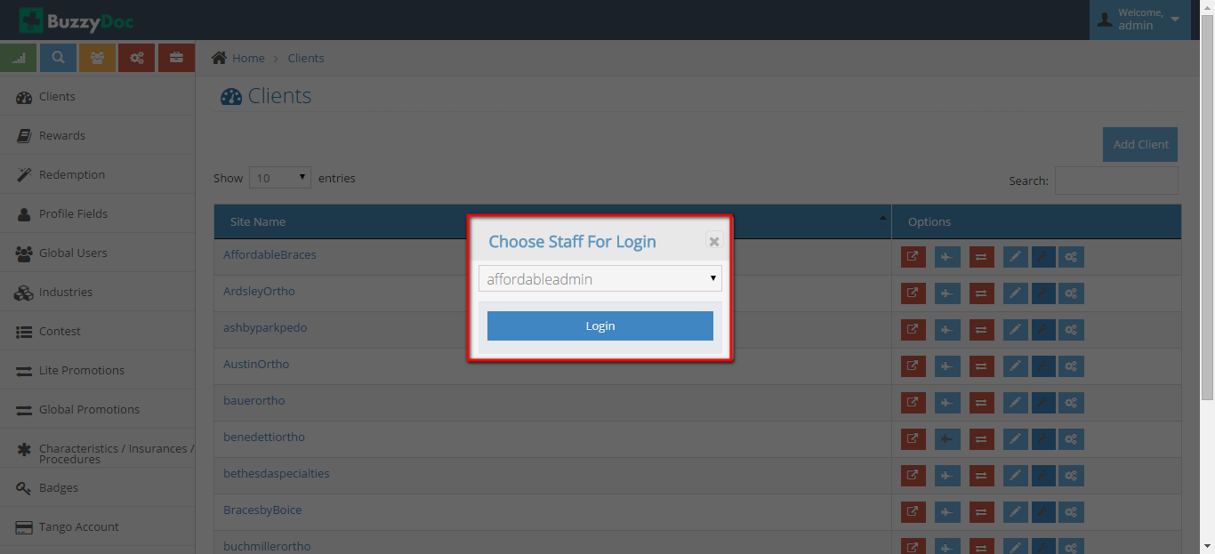

Select the Staff Member from which Super Admin wants to Login

**Staff Access Control**

Super Admin can control Staff Access by assigning some privileges to some Clients Staff and disabling some privileges for another Client’s staff

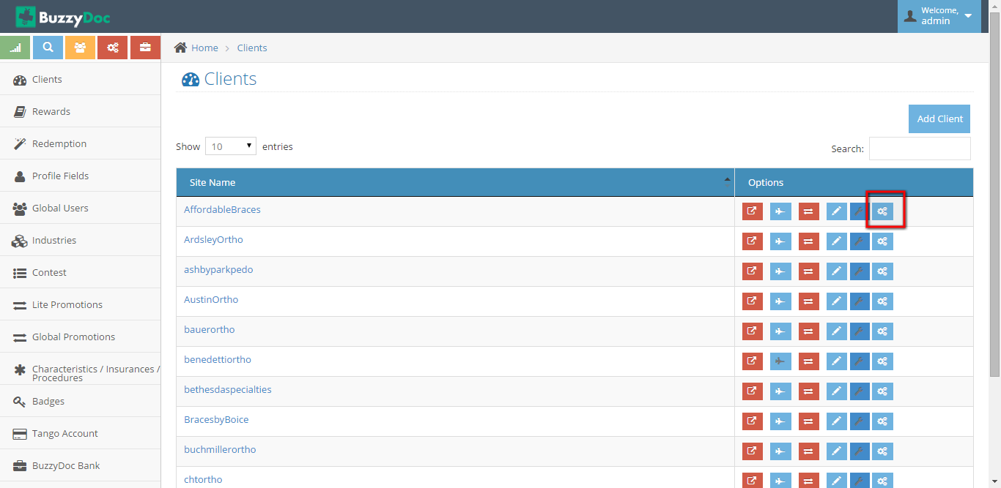

On Clicking “Staff Access Control” button,page will be navigate to new page where Super Admin can actually Set Access control for Staff Site.

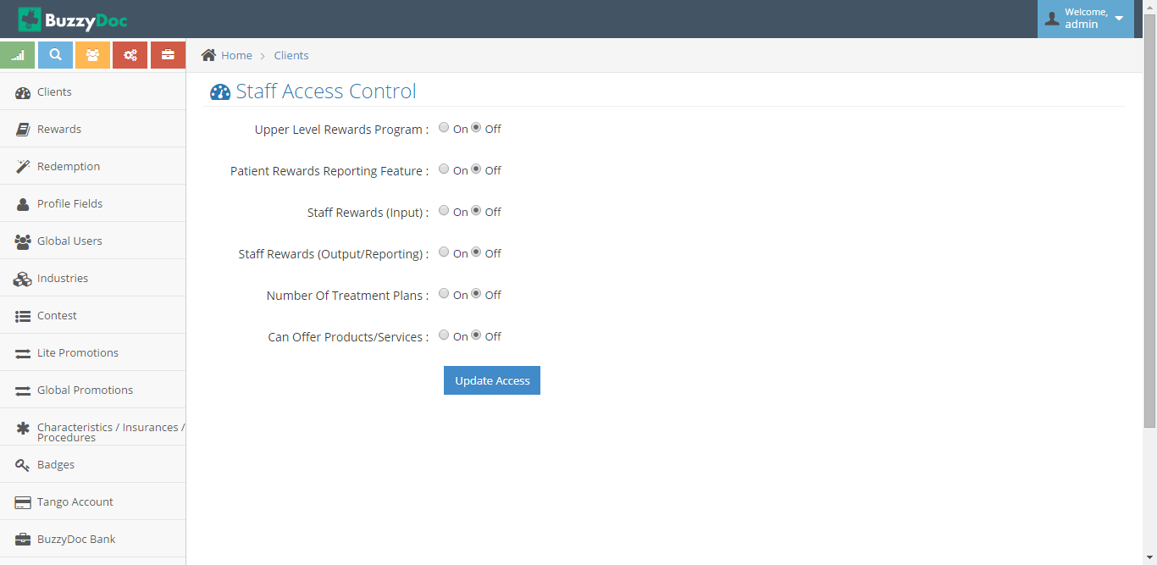

Each Time Treatment plan is added from the Staff site after giving access from Staff Access control user is able to see all the Treatment plans related to the clinic.

**2. Rewards**

Rewards are products which Patients can Redeem through Points Earned.

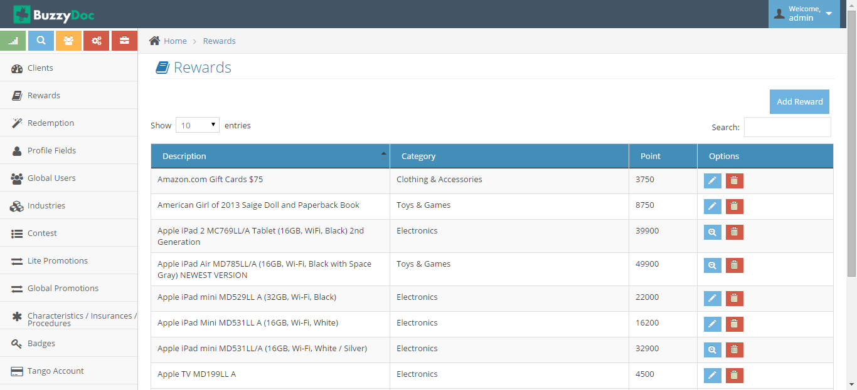

Super Admin can Add/Edit/Delete Rewards

**Add Reward**

Super Admin can Add Rewards by clicking Add Rewards button on Top Right

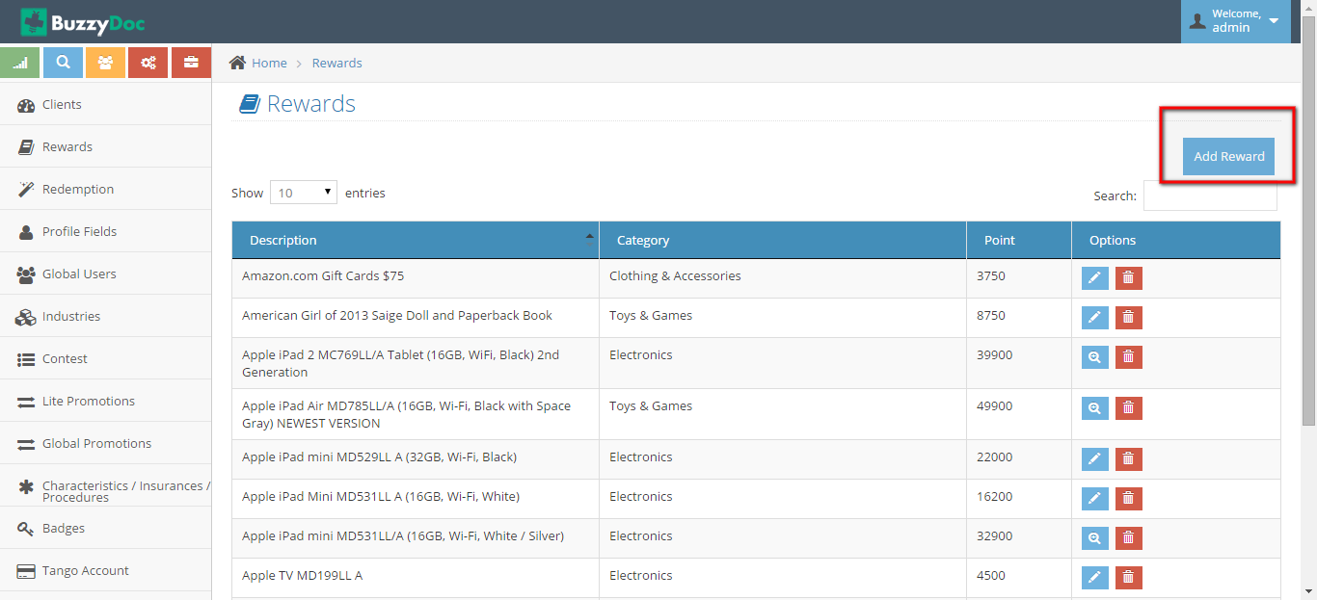

On Clicking Add Reward Button Page will be navigated to Add Reward Form

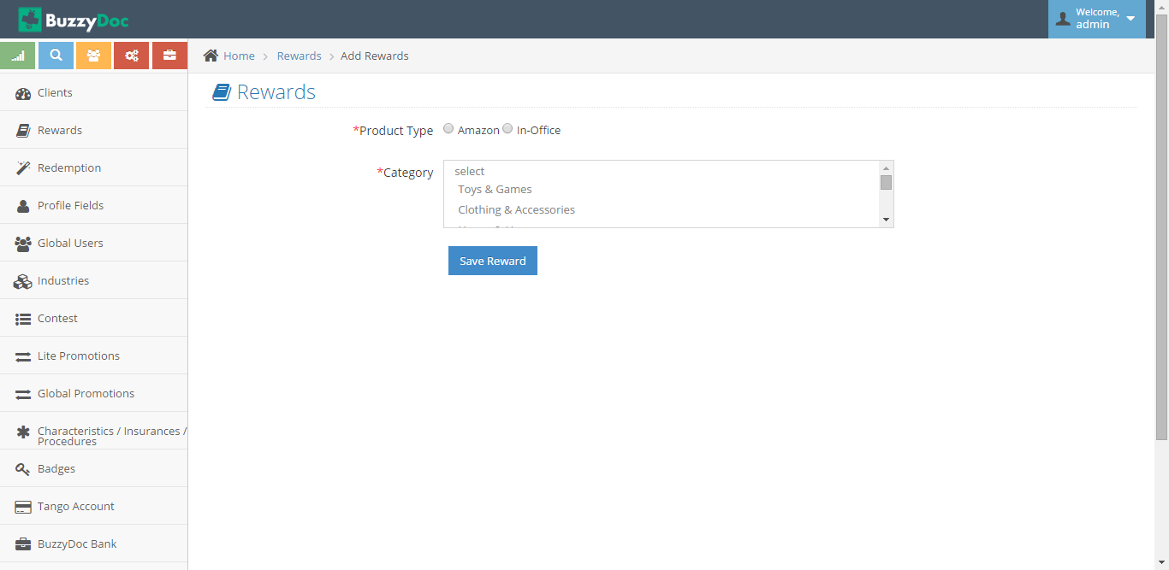

**Edit Rewards**

Super Admin can Edit Existing Rewards by clicking “Edit” button next to Reward Name

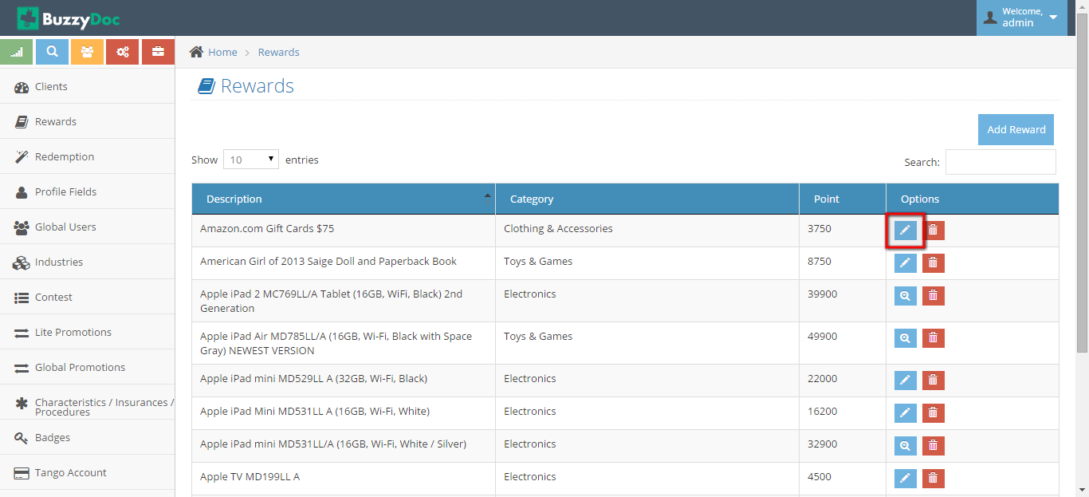

Once Super Admin Clicks on Edit button, page redirects to Reward page where Super Admin can actually Edit Rewards Information

**Delete Rewards**

Super Admin can Delete the Reward by Clicking “Delete” button. On clicking Delete button, particular Reward will be deleted.

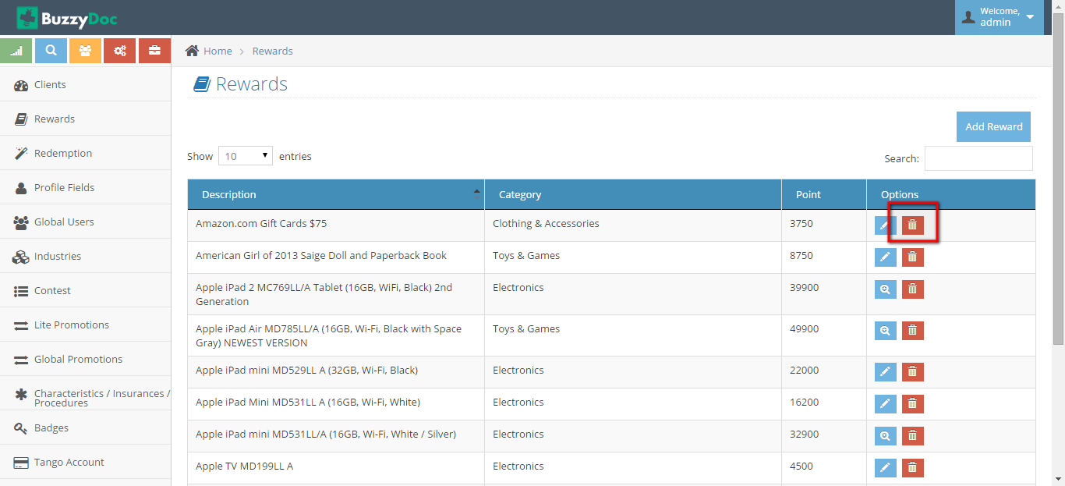

**3. Redemption**

Each Time a patient Redeems its points,status for that product will be changed to Redeemed 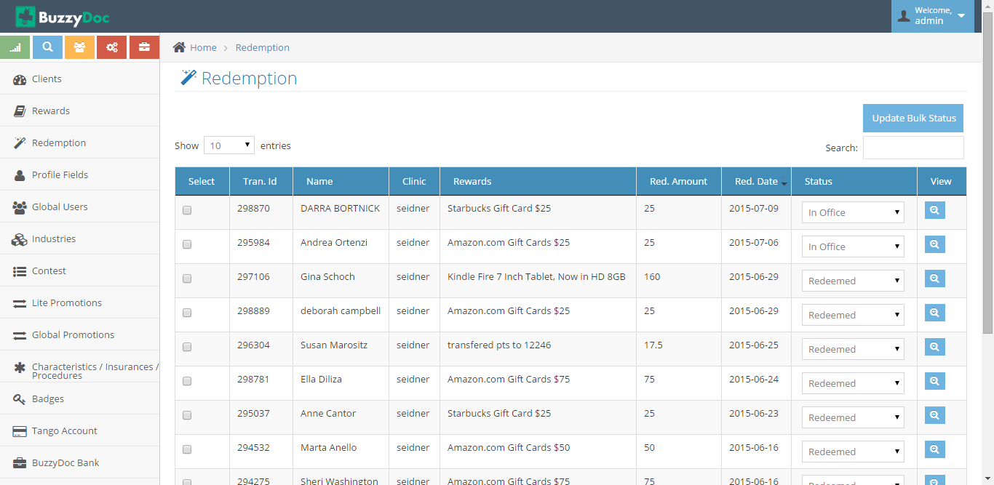

Super Admin can change its status from Redeemed to In Office, Ordered/Shipped

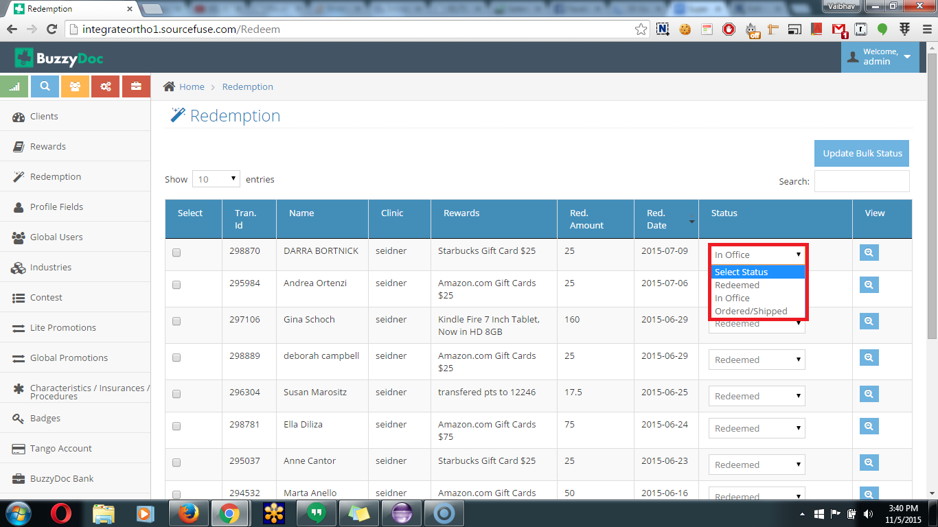

Status will be changed to “In Office” when Super Admin sees that product has been Redeemed.

Once the product is Ordered/Shipped then Super Admin will change status to Ordered/Shipped.

Super Admin can also update the Bulk Status by clicking “Update Bulk Status” button on selecting different Products

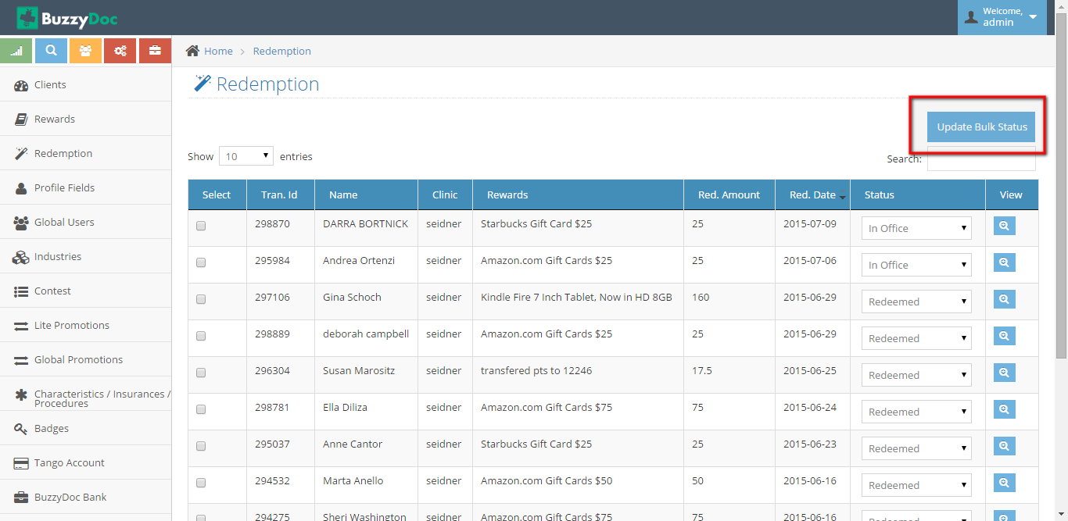

**4. Profile Fields**

Profile Fields are the fields to be used while creating a Patient Profile. These fields will be required fields while adding a patient.

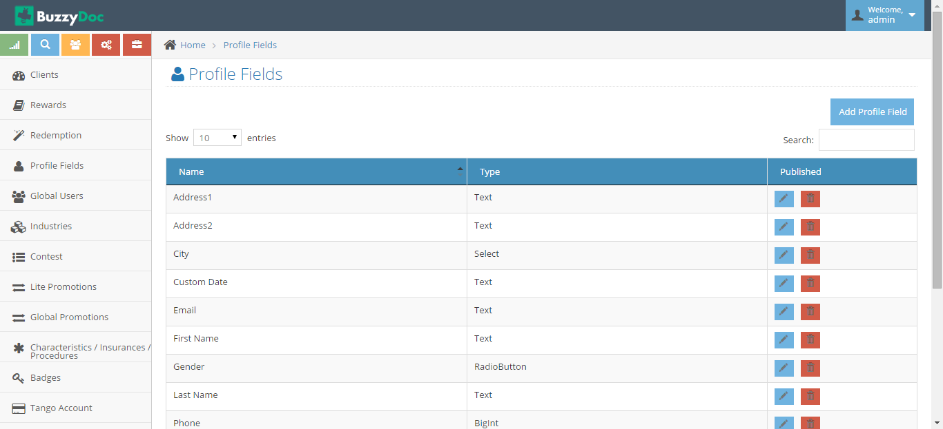

**Add Profile Field**

Super Admin can add new Profile Field by clicking “Add Profile Field” button

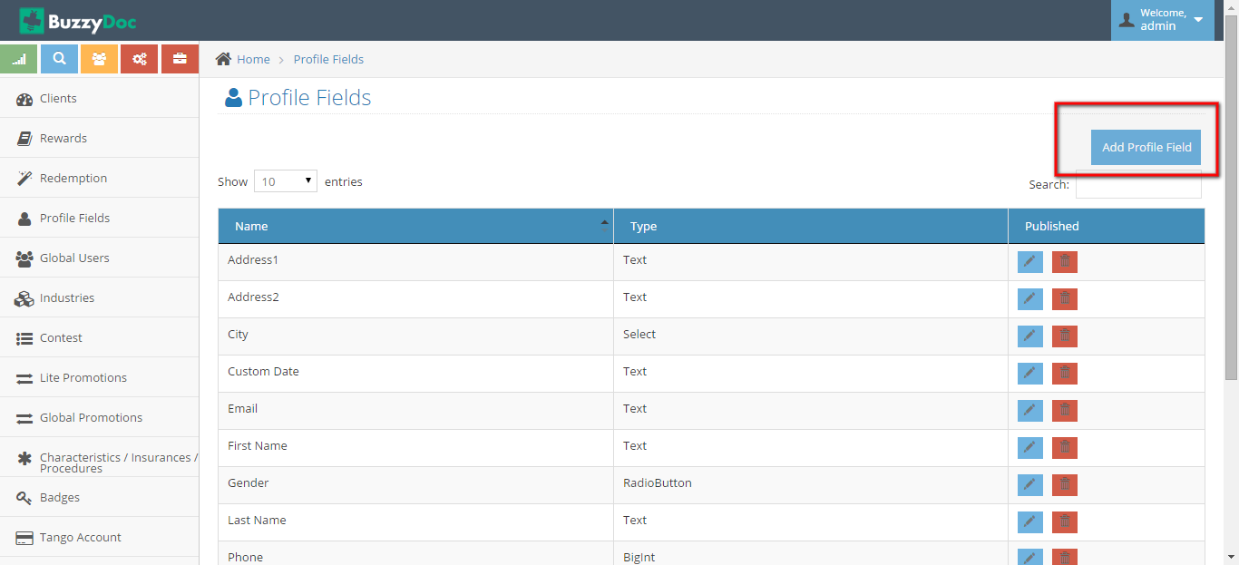

On Clicking “Add Profile Field” button Page Navigates to Add Profile Fields Form.

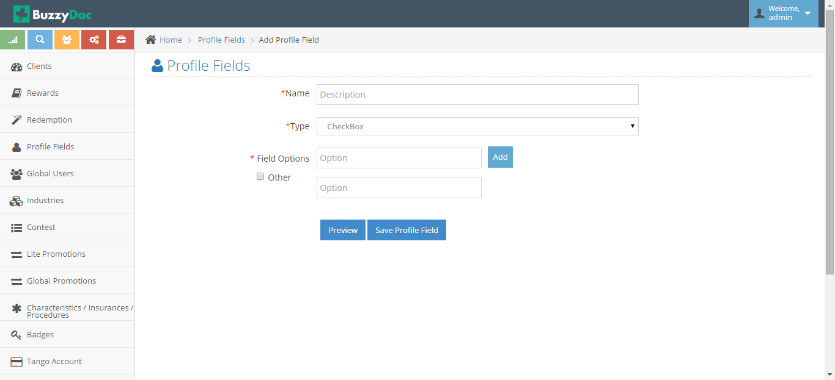

Now Fields can be added by Adding Required Information.

**Edit Profile Field**

Super Admin can also Edit Profile Field by clicking “Edit” Button next to Profile Field name.

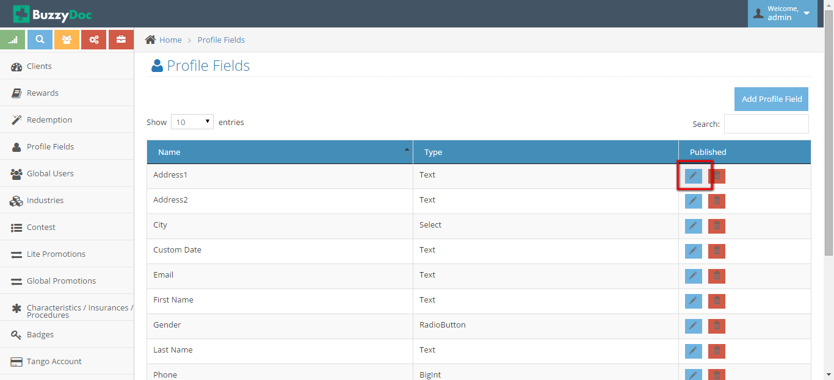

On Clicking Edit Button, Edit form shows up in which Super Admin can Edit the Profile Field

**Delete Profile Field**

On Clicking Delete button next to “Delete Profile Field” leads to delete Profile Field

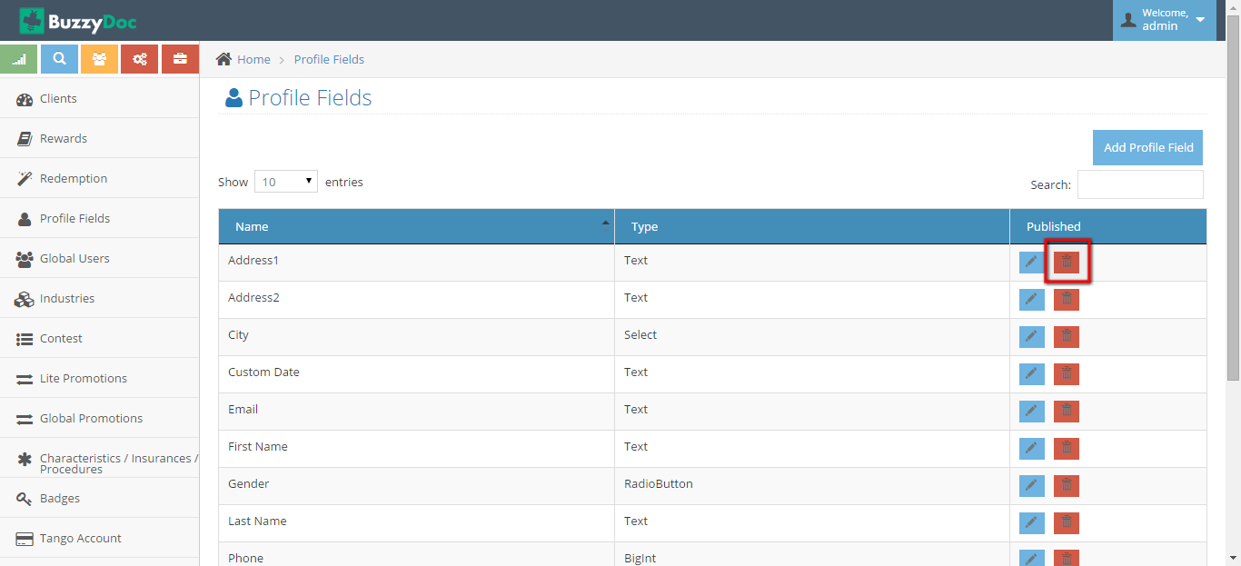

**5. Global Users**

All the patients from every Buzzydoc Client in shown under Global User. Against a user Super Admin can View Profile,Assign Card,Login to Buzzydoc site

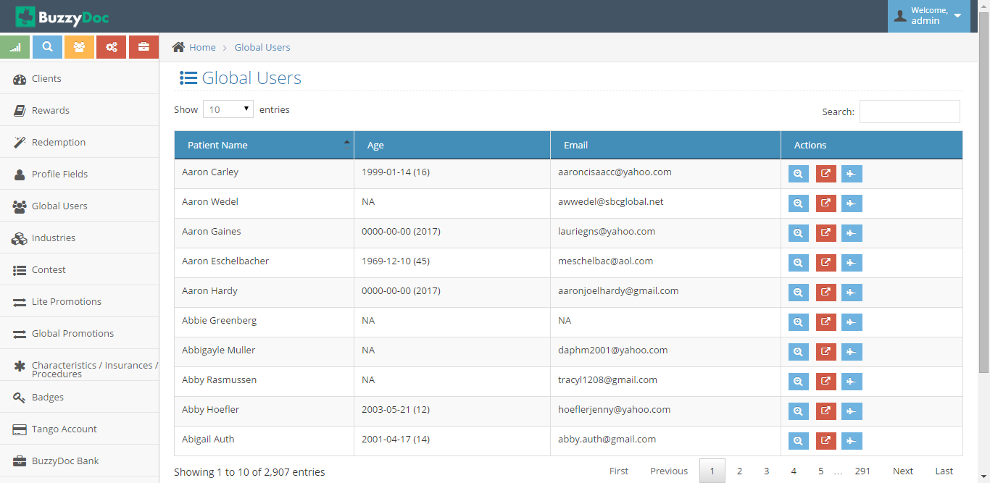

**View Profile**

Super Admin can View the profile of Global user by clicking “View Profile” button next to Patient’s Name

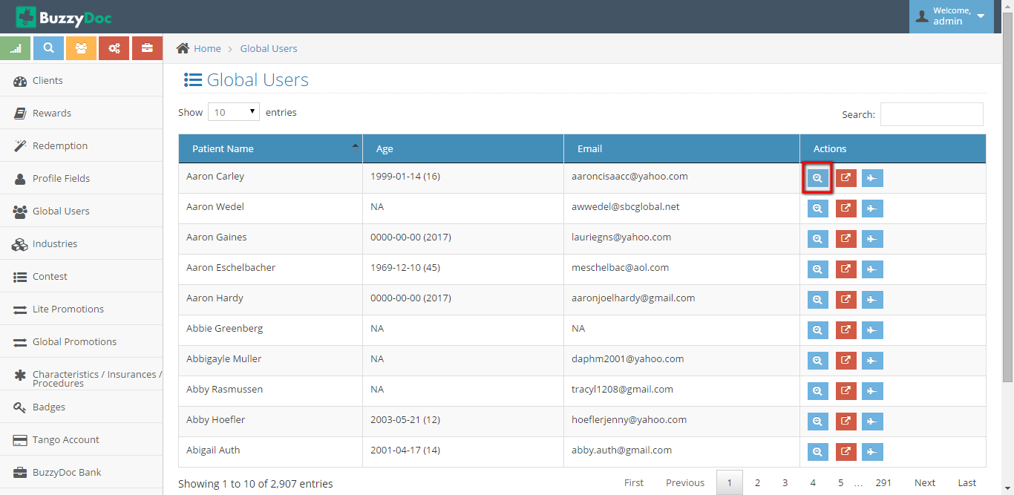

On Clicking it Patient profile will be displayed to Super Admin.

**Assign Card**

Super Admin can view which all cards have been assigned to the Patient by clicking “Assigned Card” Button

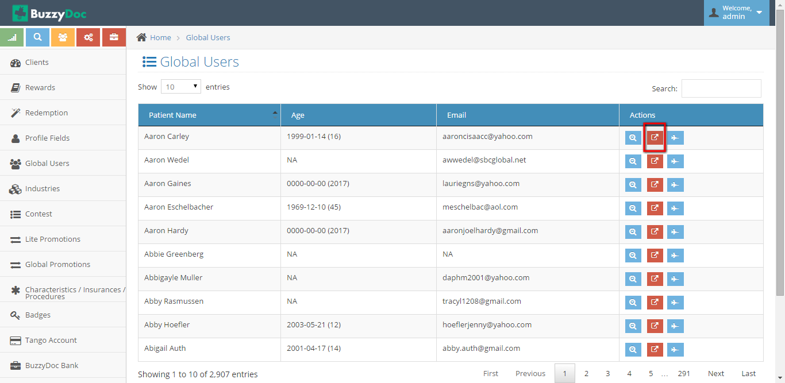

**Login to BuzzyDoc Site**

By clicking “Login to Buzzydoc site” button Super admin gets Logged into Buuzydoc site by Patients profile

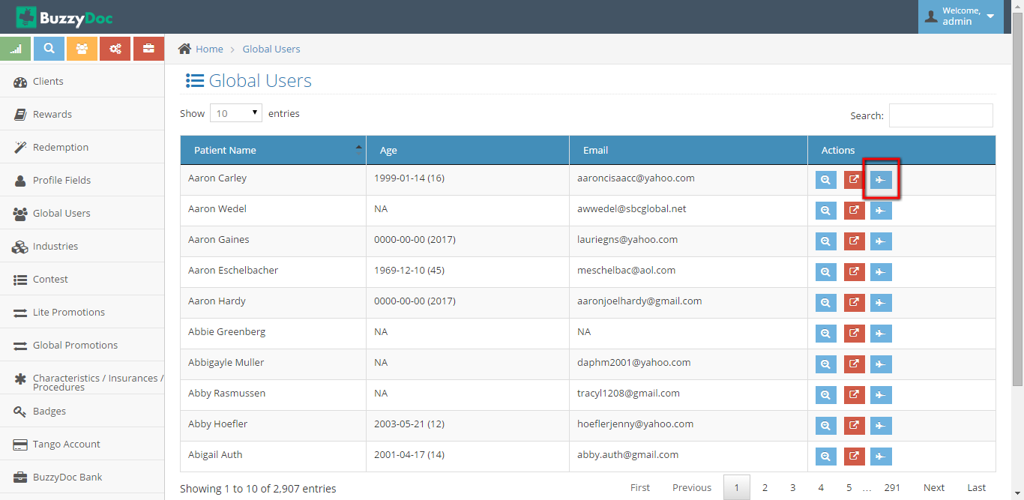

**6. Industries**

Super Admin add’s Industries in which Clients deals in.

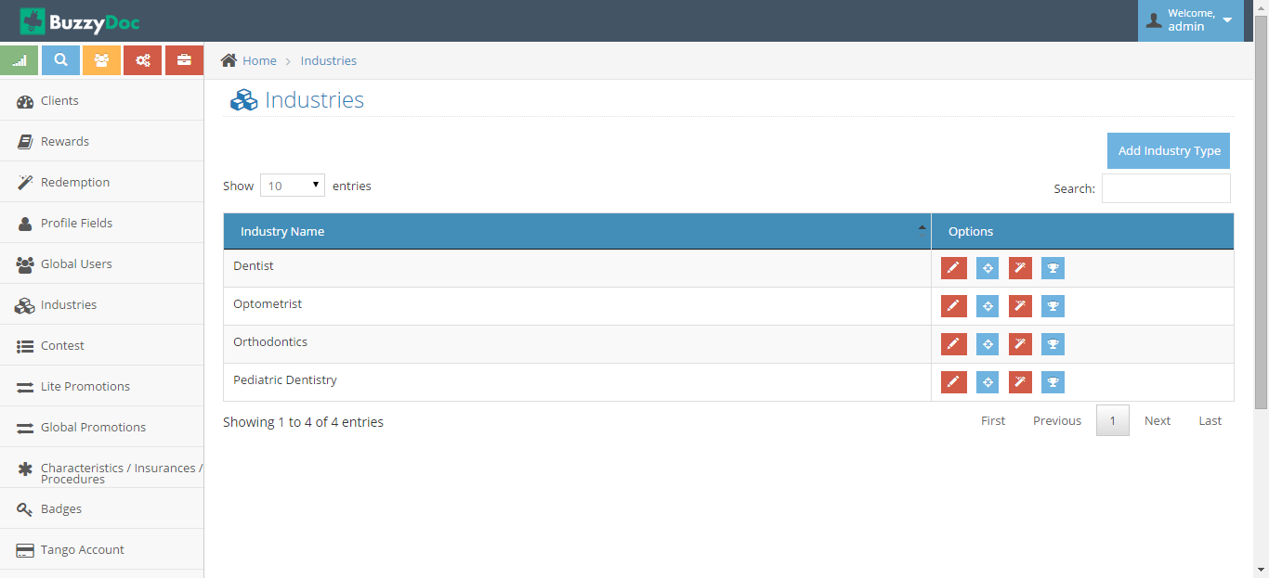

**Add Industry**

Super Admin can Add new Industry Type by clicking “Add Industry Type” button

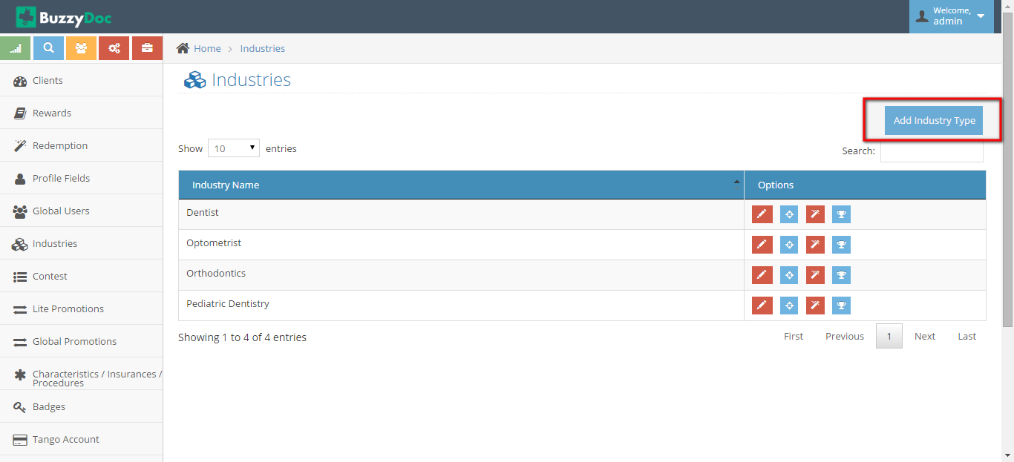

On Clicking “Add Industry Type” form to add new industry type shows up

**Edit Industry Type**

Super Admin can Edit existing Industry Type by clicking “Edit” button . It allows to Edit existing Industry Type

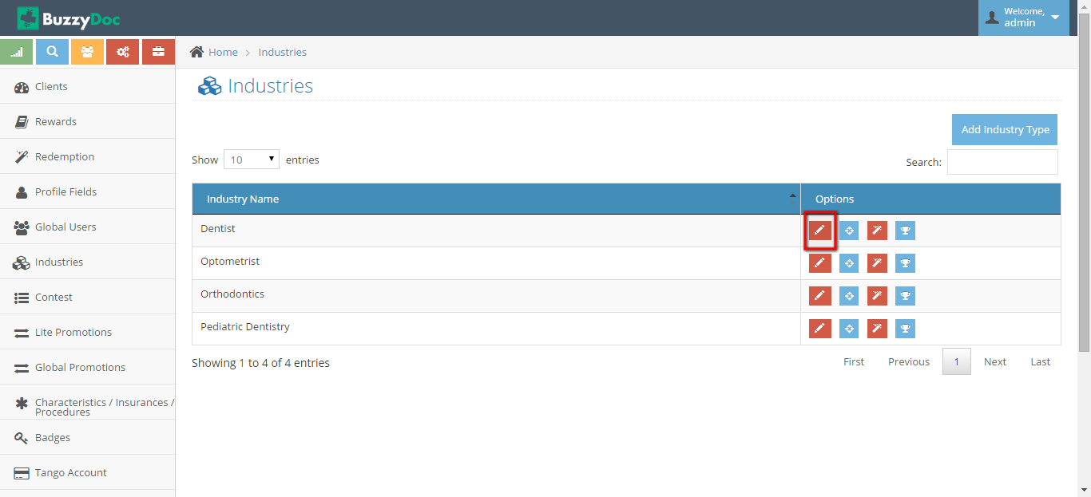

**Manage Lead Level**

It allows to Manage Lead Level which is

**6. Lite Promotion**

Lite promotion allows to manage Promotions which are Lite.

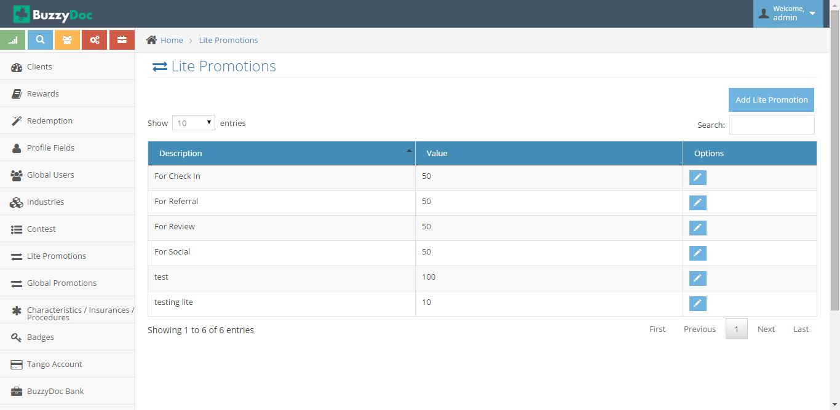

**Add Lite Promotions**

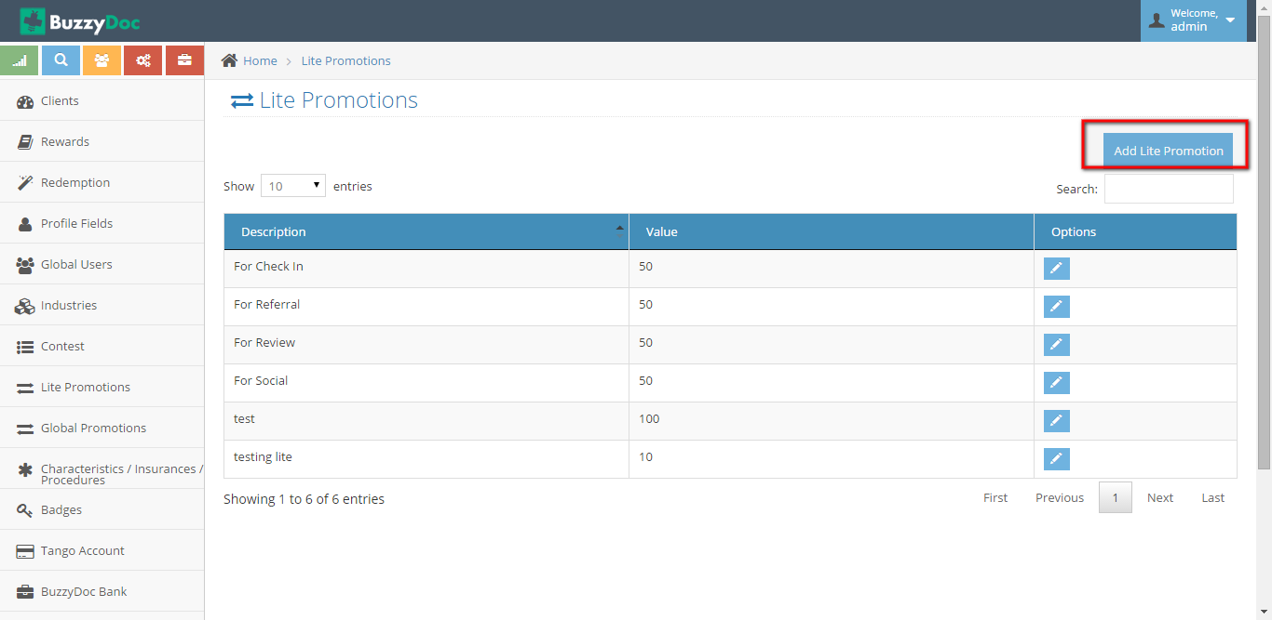

On Clicking Add Lite Promotion button Page redirects to Form which allows to add New Lite Promotion

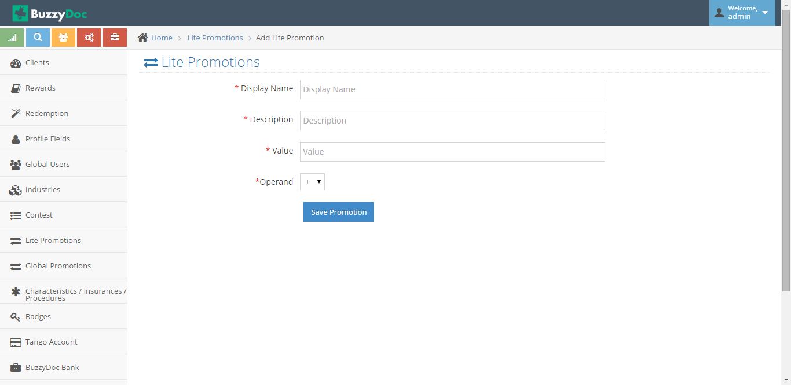

**7. Global Promotion**

Global Promotion are the Promotions for all the clients.

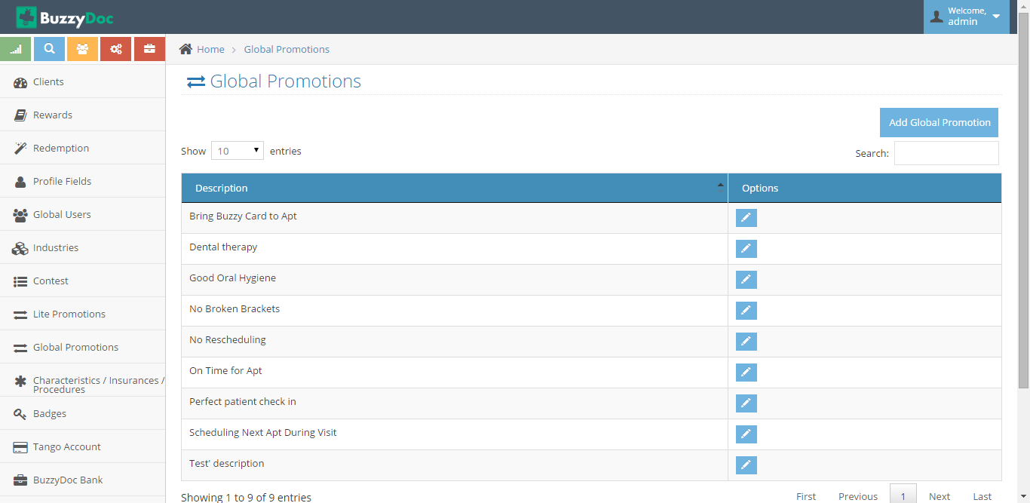

**Add Global Promotion**

On clicking Add Global Promotion button on Top Right, form to add new Global Promotion will show up

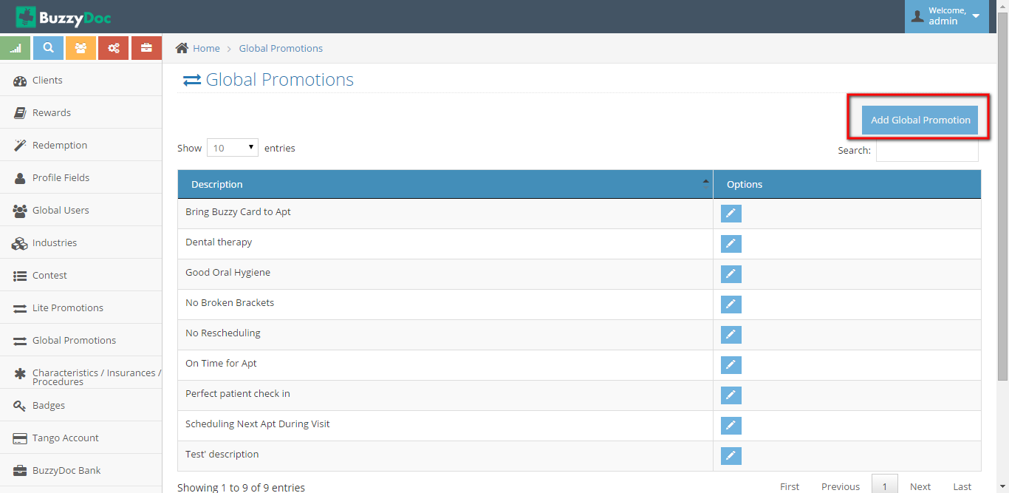

**8. Characteristic/Insurance/Procedure**

Characteristic are the features of particular Practice.Insurance are the type of Insurance Clinic Accept whereas Procedure are the method which clinics follow

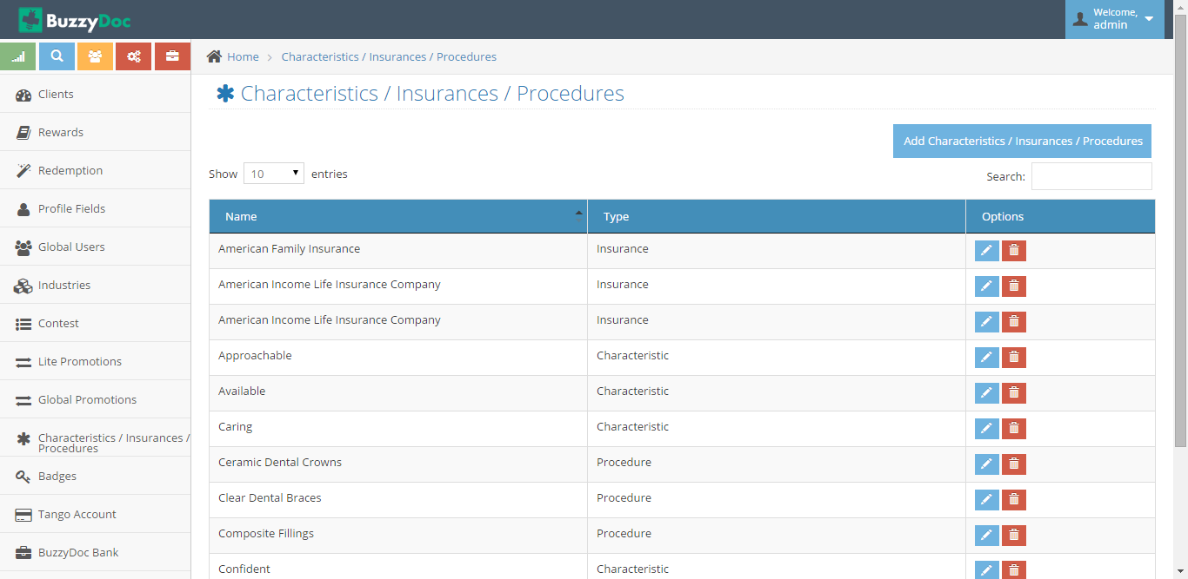

**Add Characteristic/Insurance/Procedure**

On clicking Characteristic/Insurance/Procedure button new form to add characteristic/insurance/procedure will be redirected.

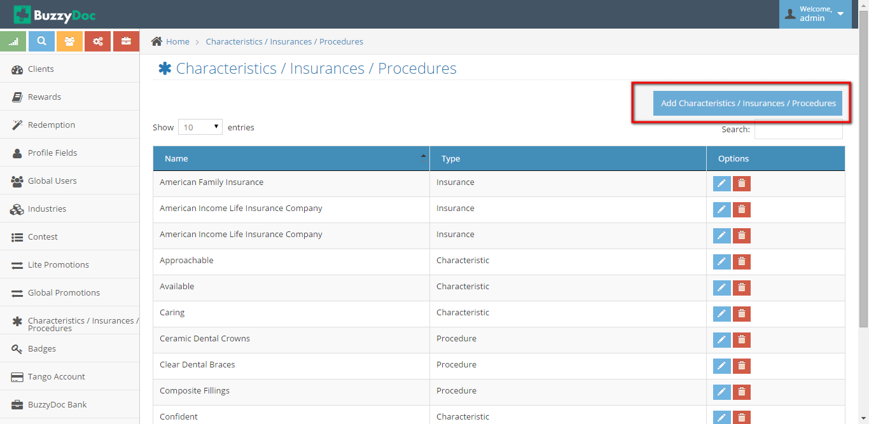

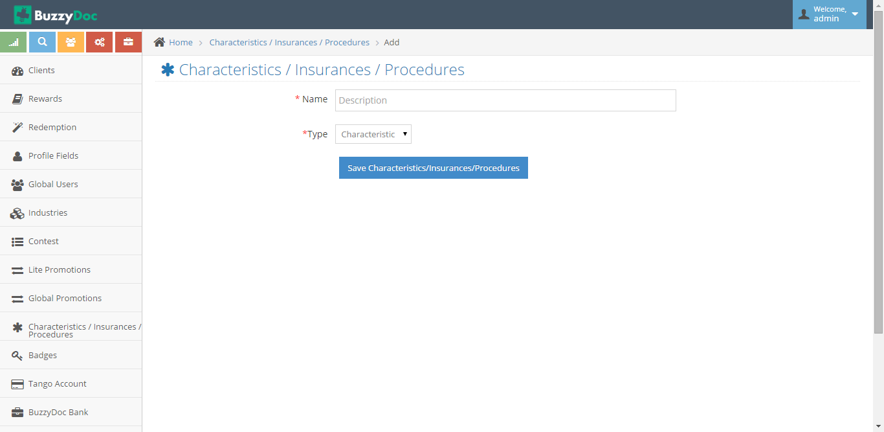

Through Type Dropdown Super Admin can select and add Characteristic,Insurance or Procedure

**Edit Characteristic/Insurance/Procedure**

By clicking Edit button Super Admin can change it’s Type and Description.

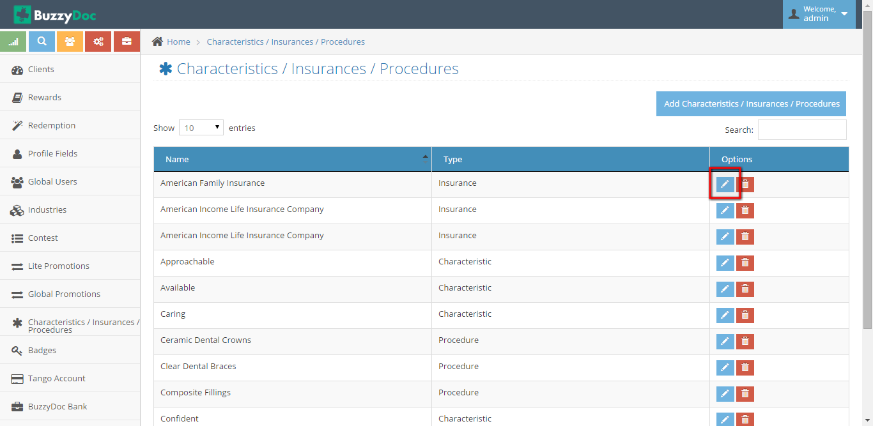

**Delete** **Characteristic/Insurance/Procedure**

On clicking Delete button, Characteristic/Insurance/Procedure gets deleted

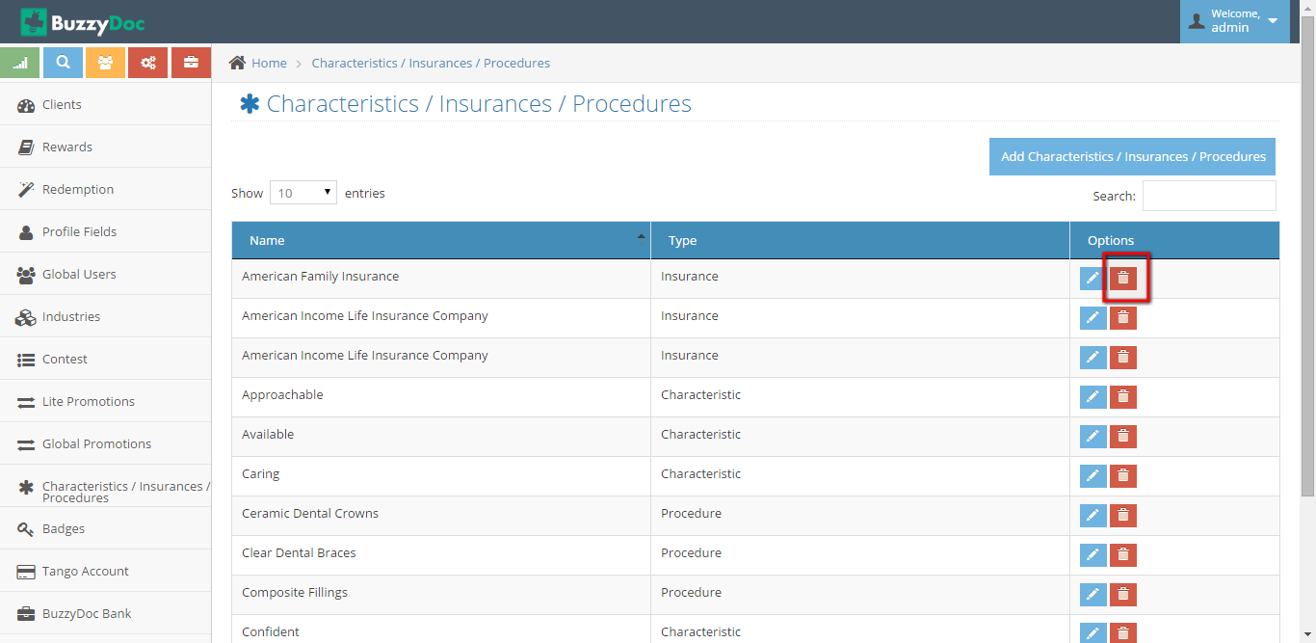

**9. Badges**

Badges are little bits of digital flair that User earn on completing set of action which are defined on adding New Badge.

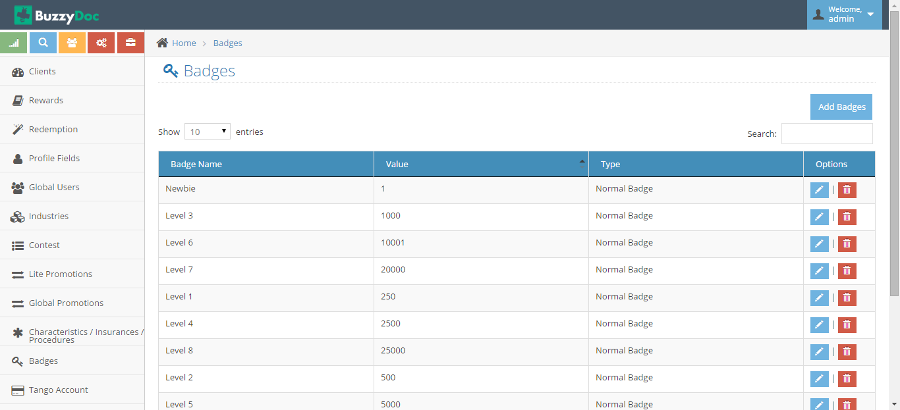

**Add Badge**

Super Admin can Add New Badge by clicking “Add Badge” button. On clicking Add Badge button Super Admin have to define value for that Badge,Name and Description

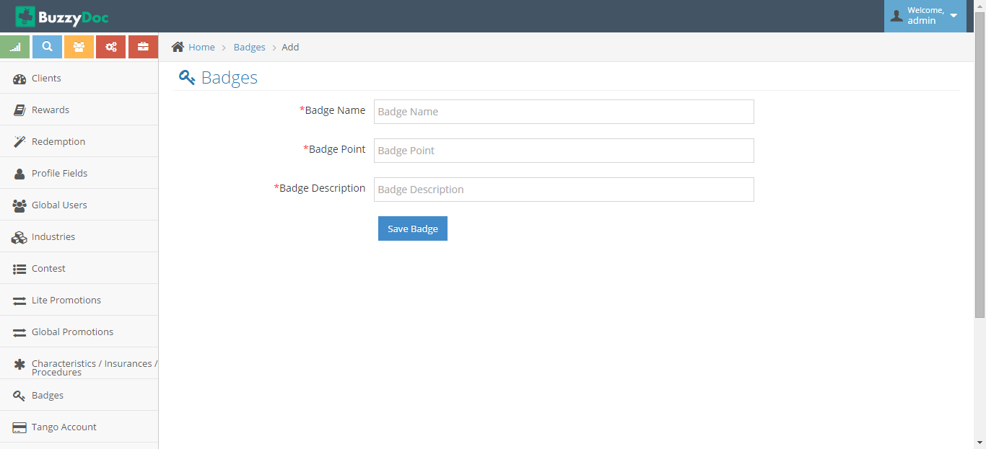

**Edit Badge**

Super Admin can Edit Existing Badges by clicking Edit Badge button. Through it Super Admin can Modify the Badge Description, Points and name

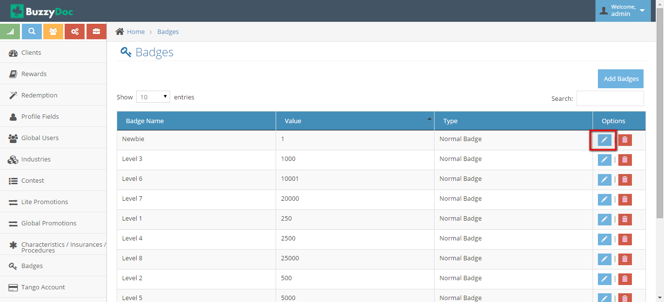

**Delete Badge**

Super Admin can also delete the Badges from existing list by clicking Delete Badge button.

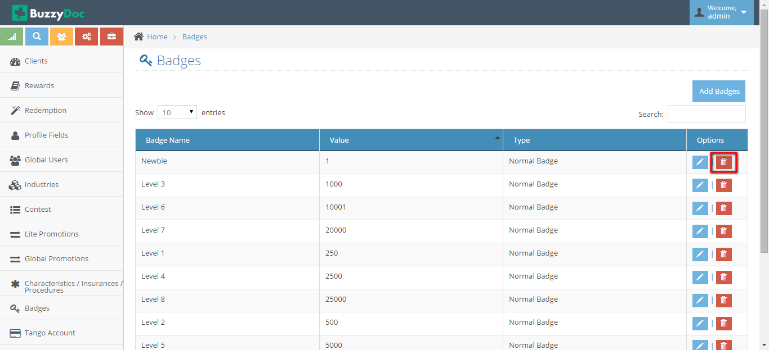

**10. Tango Account**

Tango Account is the account through which all the debit will take place. If a user redeems his/her points then payment to order their products will done through Tango Account.

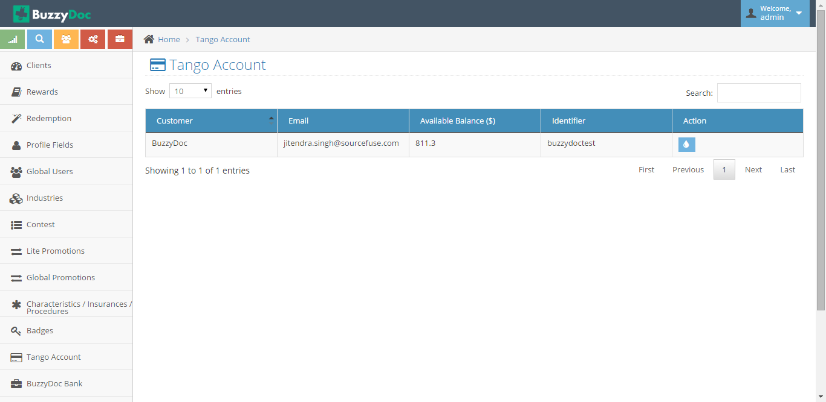

**Add Fund**

Super admin have to add funds so that all the redemptions made by patients goes without any disturbance.

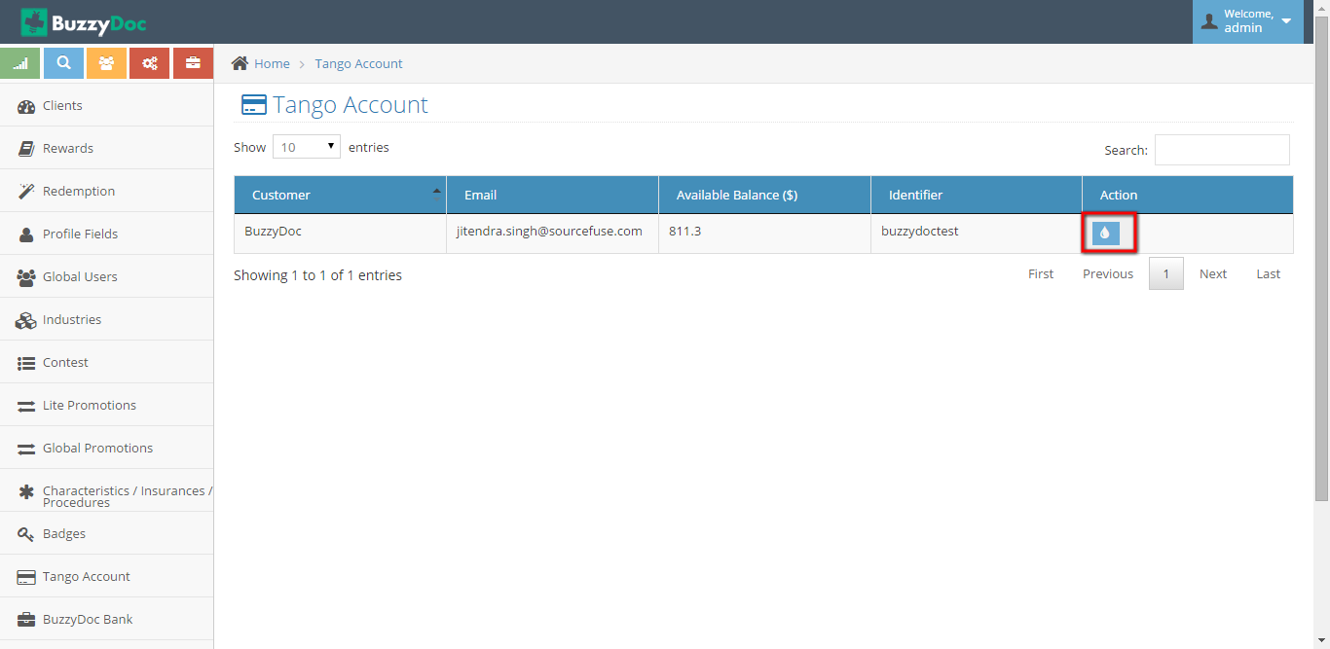

On Clicking Add Fund button page will be redirected to Add Fund form, where

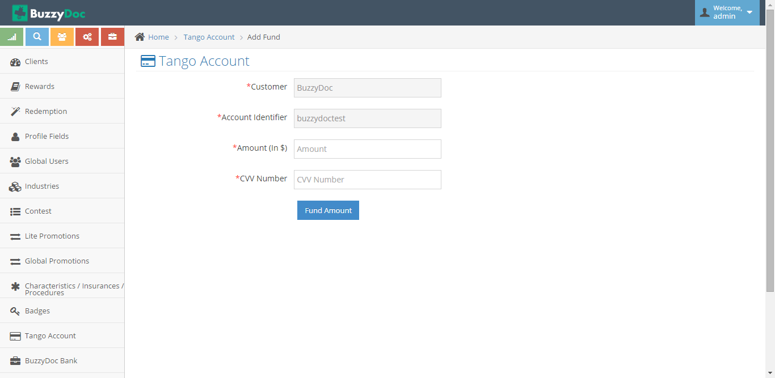

**11. BuzzyDoc Bank**

BuzzyDoc Bank describes which all clinic are related, what are their Outstanding amount,Minimum balance etc.

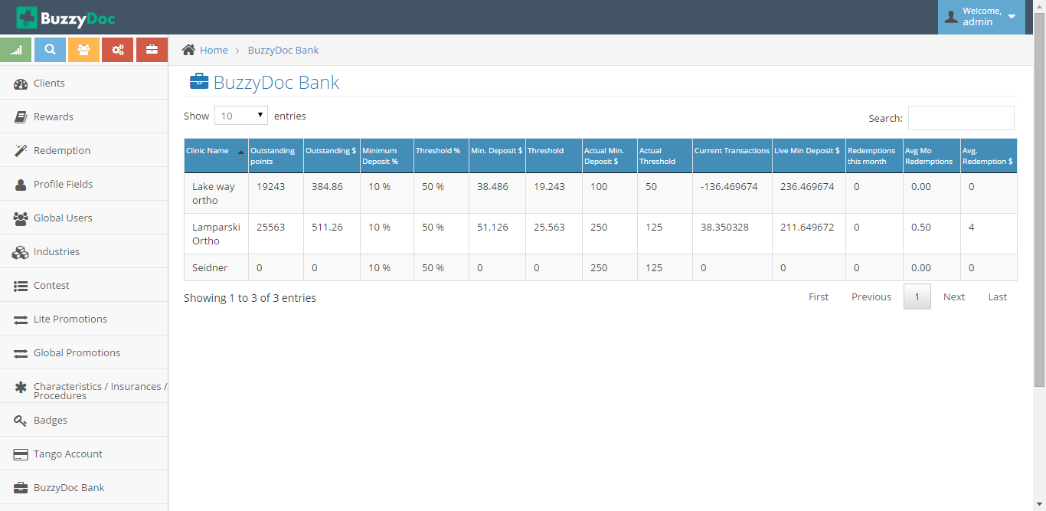

**12. Manage Balance Status**

On Partial Redemption by patient in that case X amount has to be credited back to the clinic , then on reaching amount 100$ status needs to be changed to “Completed”

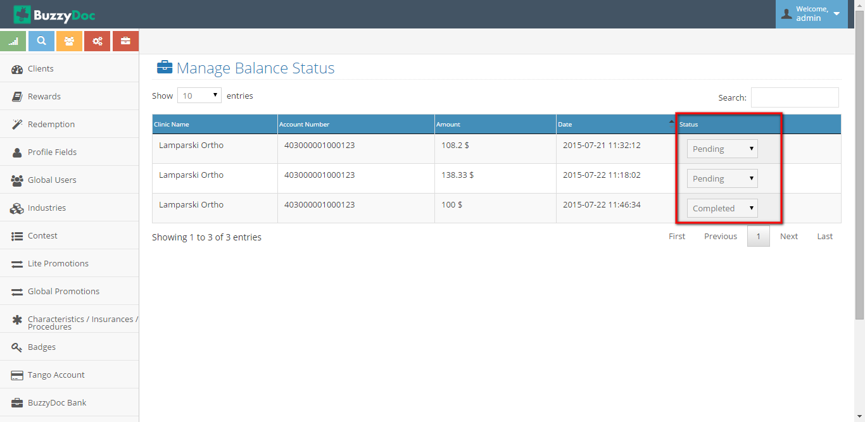

**13. Training Video**

It allows to add edit and delete Video which will be shown on Staff Site under Notification Tab.

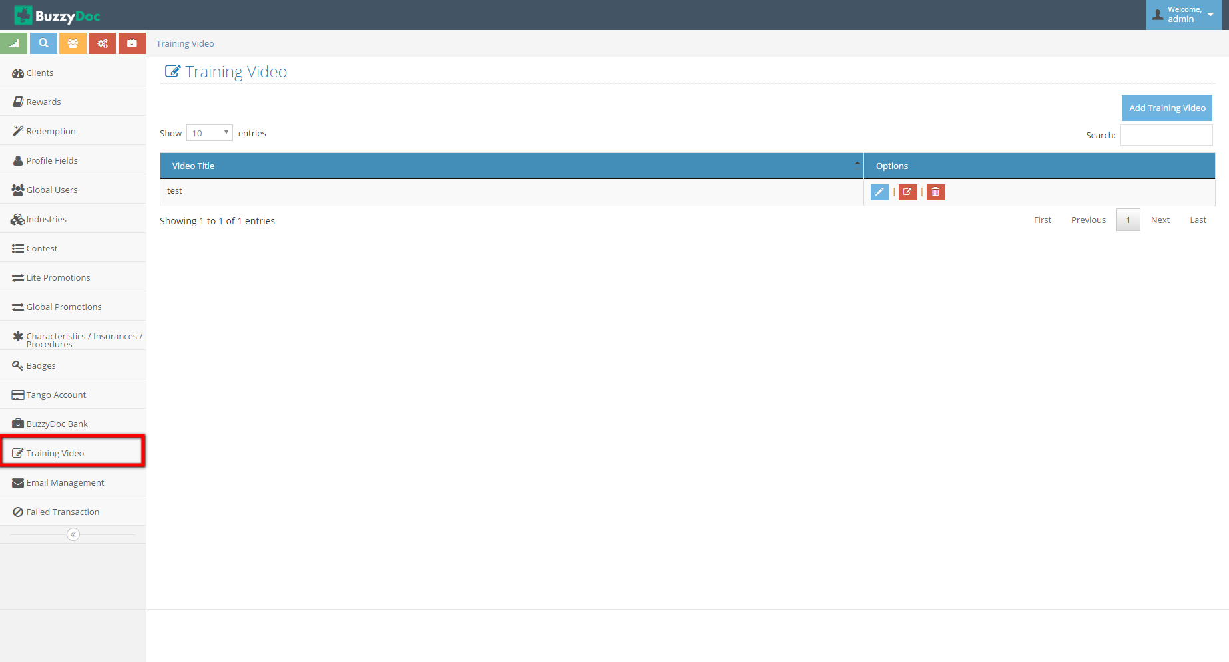

Watched by button allows to know which Staff has watched the video which has been added.

Super Admin can Add Training Video by clicking “Add Video Training” button on top right corner.

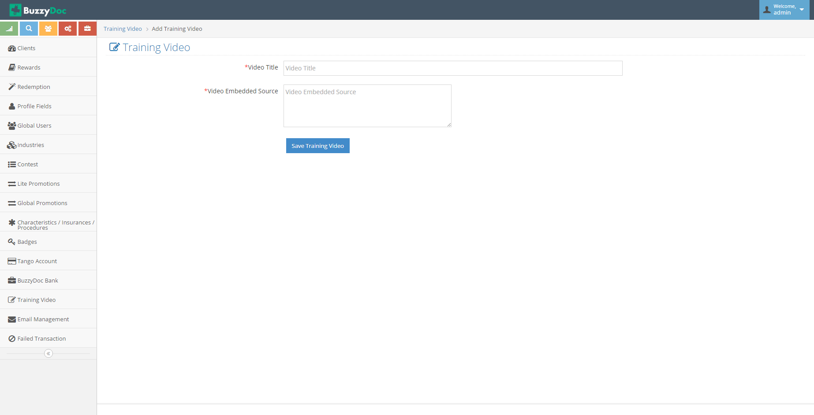

Super Admin has to give Video title which will be displayed on the Video description and Video Embedded code which will be the link of the video.

**14. Email Management**

It allows to Edit Email content for different Email type directly.

**15. Failed Transactions**

If in case of Incorrect card details added from Staff Site of the Super Doc then Alert will be shown under this section.

16